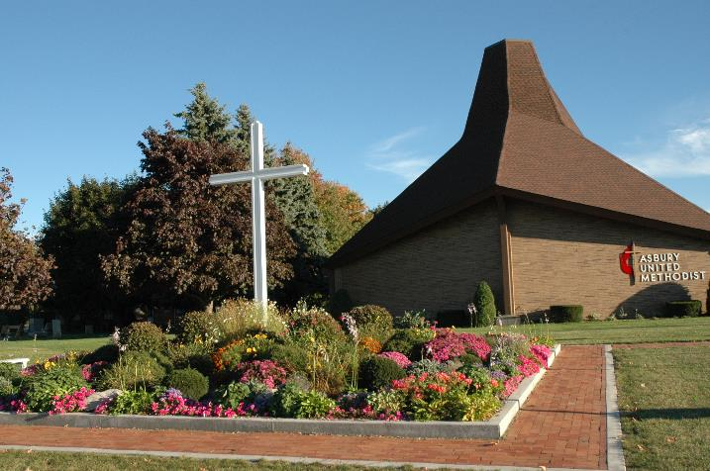
Celebrating Christ,
Sharing His Love,
Making Disciples

Asbury
United
Methodist
Church

Although we are presently not able to gather for worship in one place, we are still connected in Christ.

Welcome to Worship
April 19, 2020

He is risen!
He is risen indeed!
He is Risen!
He is risen indeed!

Let us sing or listen
My Redeemer Lives
https://www.youtube.com/watch?v=IBbSyig8vQ0
Hallelujah/Your Love is Amazing
https://www.youtube.com/watch?v=pWT3Hd6WqE0

Prayer
Scripture: Psalm 32 Matthew 26:46-56

You Are My Hiding Place
https://www.youtube.com/watch?v=uUx2WcC9JKo

Message: Conquered: Fear
Prayer

Sing or Listen to
Stand in Your Love
https://www.youtube.com/watch?v=MHLEZzyAZrI
Victory Chant
https://www.youtube.com/watch?v=7wWynUbEYg0

Benediction

